**LAB : 3**

**OBJECTIVE :**

1. Write the ﬂow of events and specify all ﬁelds for the use case UpdateTariff that you drew in Lab 2. Do not forget to specify any relationships.
2. Draw a class diagram representing a book deﬁned by the following statement: “A book is composed of a number of parts, which in turn are composed of a number of chapters. Chapters are composed of sections.” Focus only on classes and relationships.
3. Add multiplicity to the class diagram you produced in Exercise (b).
4. Draw an object diagram representing the ﬁrst part of this book (i.e., Part I, Getting Started). Make sure that the object diagram you draw is consistent with the class diagram of Exercise (b).

**Requrements :**

(a) Windows PC (Windows 7/8/10) / Mac

(b) Star UML Tool

**Procedure :**

1. Write the ﬂow of events and specify all ﬁelds for the use case UpdateTariff that you drew in Lab 2. Do not forget to specify any relationships.

* **Use case name** UpdateTariff
* **Participating actor** Initiated by CentralComputerSystem
* **Flow Of Events** 
  1. The CentralComputerSystem activates the “UpdateTariff” function of the ticket distributors available on the network.
     1. The ticket distributor disables the traveler interface and posts a sign indicating that the ticket distributor is under maintenance.
     2. The ticket distributor waits for the new database from the CentralComputerSystem
  2. After waiting a minute for the ticket distributors to reach a waiting state, the CentralComputerSystem broadcasts the new database.
     1. 5. The ticket distributor system receives the new database of tariff. Upon complete, the ticket distributor sends an acknowledgement to the CentralComputerSystem
     2. After acknowledgment, the ticket distributor enables the traveler interface and can issue tickets at the new tariff.
  3. The CentralComputerSystem hecks if all ticket distributors have acknowledged the new database. If not, the CentralComputerSystem invokes the Check NonRespondingDistributors use case.
* **Entry condition** The ticket distributor is connected to a network reachable by the CentralComputerSystem.
* **Exit condition**
  + The ticket distributor can issue tickets under the new tariff, OR •
  + The ticket distributor is disabled and displays a sign denoting that it is under maintenance.
* **Quality requirements**
  + The ticket distributor stays ofﬂine at most 2 minutes and is considered out-of-order otherwise.

1. Draw a class diagram representing a book deﬁned by the following statement: “A book is composed of a number of parts, which in turn are composed of a number of chapters. Chapters are composed of sections.” Focus only on classes and relationships.

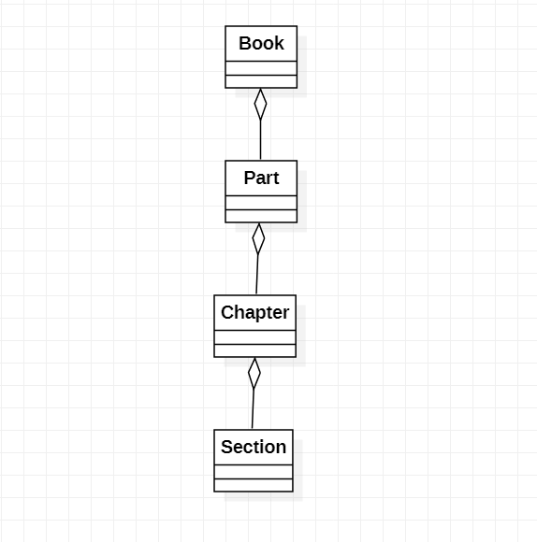

1. Add multiplicity to the class diagram you produced in Exercise (b).

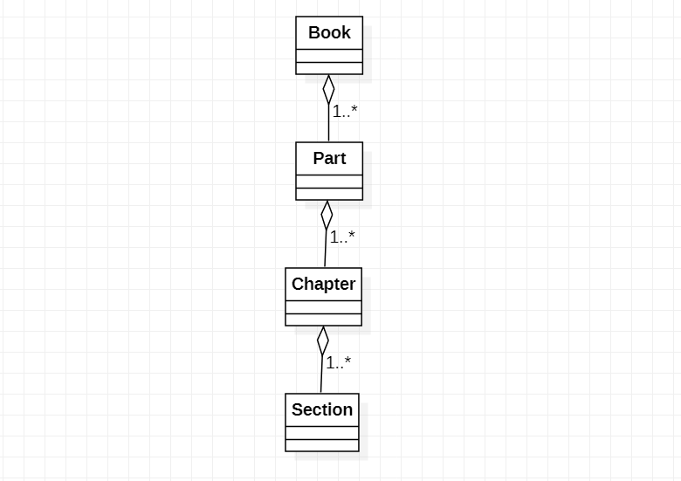

1. Draw an object diagram representing the ﬁrst part of this book (i.e., Part I, Getting Started). Make sure that the object diagram you draw is consistent with the class diagram of Exercise (b).

